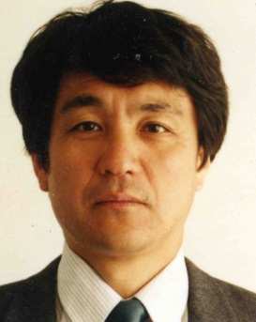
Tsukasa Iwashina

National Museum of Nature and Science, Japan
Director, Department of Botany; Dorector, Tsukuba Botanical Garden,
Professor, Graduate School, Tokyo University of Agriculture and Technology

Chemotaxonomy, Chemical adaptation of plants to environmental stresses,
Contribution of flavonoids to flower colors

Academic achivements (extraction)
Murai, Y., R. Takahashi and Tsukasa Iwashina, 2013. New flavonol triglycosides from the leaves of soybean cultivars. Nat. Prod. Commun. 8: 453-456.
Sakaguchi, K. J. Kitajima and T. Iwashina, 2013. Kaempferol 3,7,4´-glycosides from the flowers of Clematis cultivars. Nat. Prod. Commun. 8: 1093-1094.
Na C.S., Y.H. Lee, Y. Murai, T. Iwashina, T.W. Kim and S.H. Hong, 2013. Flavonol 3,7-diglycosides from the aerial parts of Sicyos angulatus (Cucurbitaceae) in Korea and Japan. Biochem. Syst. Ecol. 48: 235-237.
Uehara, A., M. Nakata, J. Kitajima and T. Iwashina, 2012. Internal and external flavonoids from the leaves of Japanese Chrysanthemum species (Asteraceae). Biochem. Syst. Ecol. 41: 142-149.
Sakaguchi, K., J. Kitajima and T. Iwashina, 2012. Kaempferol tri- and tetraglycosides from the flowers of Clematis cultivar. Nat. Prod. Commun. 7: 173-174.
Iwashina, T., J. Kitajima and T. Takemura, 2012. Flavonoids from the leaves of six Corylopsis species (Hamamelidaceae). Biochem. Syst. Ecol. 44: 361-363.
Uehara, A. and T. Iwashina, 2012. Flavonoids from the Japanese monotypic genus, Nipponanthemum. Nat. Prod. Commun. 7: 1005-1006.
Mizuno, T., Y. Okuyama and T. Iwashina, 2012. Phenolic compounds from Iris rossii, and their chemotaxonomic and Systematic significance. Biochem. Syst. Ecol. 44: 157-160.
Mizuno, T., T. Yabuya, N. Sasaki and T.Iwashina, 2012. Phenolic compounds, including novel C-glycosylflavone, from the flowers of the tall bearded iris cultivar ‘Victoria Falls’. Nat. Prod. Commun. 7: 1591-1594.

