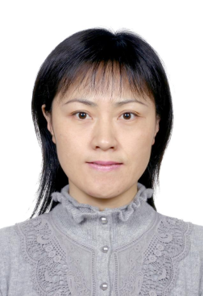
1、简介：陈畅，女，中科院生物物理研究所研究员，创新研究课题组长（PI），博士生导师，国家杰出青年基金获得者，生物大分子国家重点实验室副主任，国家重大科学研究计划 (蛋白质研究计划“973”)项目首席科学家。

2、简历&研究组工作摘要
1986-1990 南开大学化学系，理学学士学位
1990-1993 北京师范大学化学系 理学硕士学位
1993-1996 北京大学技术物理系 理学博士学位
1996-1998 中科院生物物理研究所 助理研究员。
1998-2000 中科院生物物理研究所 副研究员，获英国皇家学会K. C. Wong Fellowship及受英国皇家学会 Joint project资助在英国国立食品研究所（Institute of Food Research, UK）访问学者。
2000-至今 中国科学院生物物理研究所 创新研究课题组长（PI）。2004年晋升研究员。2004.12－2005.03 英国剑桥MRC (Medical Research Council)访问学者。

主要学术任职情况：
- 生物大分子国家重点实验室副主任；
- 中国生物物理学会理事，副秘书长；中国生化与分子生物学学会理事；北京生化与分子生物学学会理事；
- 中国生物物理学会自由基生物学与医学专业委员会副主任；亚洲国际自由基学会委员；
- 国际自由基生物学期刊Free Radical Research编委; Redox Biology编委；《生物物理学报》副主编；《生物物理与生物化学进展》编委
- 南京大学生命科学院兼职教授

研究组工作摘要
细胞的氧化还原调控失衡是导致亚健康、衰老、神经退行性疾病、炎症、肿瘤、糖尿病等的重要因素，因此，细胞氧化还原调控的分子机理研究具有重要理论和实际意义。本课题组致力于揭示生命活动中氧化还原相关小分子(自由基，天然抗氧化剂等)和大分子的对白，揭示蛋白质的功能与细胞氧化还原状态的关系。近年研究发现：机体在应激条件下产生的一氧化氮等活性氮及活性氧小分子通过对蛋白质中氧化还原敏感的半胱氨酸巯基进行修饰，影响蛋白的结构、活性、定位、组装和降解，从而调控蛋白的功能和细胞信号传导，最终在生理和病理过程中发挥作用。这种修饰称为氧化还原依赖的蛋白质巯基翻译后修饰（Redox based post-translational modification of protein），包括：亚硝基化修饰(-SNO)、不同程度的氧化修饰（-S-S-; -S-OH; -SO₃）、谷胱甘肽化修饰(-SSG)等，与磷酸化修饰一样，是两种进化上高度保守的蛋白翻译后修饰之一。课题组主要工作分以下三个方面：
- 蛋白质巯基修饰的生理功能研究：课题组在一氧化氮对蛋白质巯基亚硝基化修饰的功能和研究方法方面进行了系统研究，目前主要进行蛋白质亚硝基化修饰及其它巯基修饰在蛋白质质量控制及疾病发生中的功能研究。
- 一氧化氮的生物活性和平衡调控及作用机制：提出一氧化氮生物活性由生成和代谢“双闸门”调控的观点，揭示了一氧化氮代谢调控关键蛋白GSNOR在细胞凋亡、分化及学习记忆中的作用。将系统阐述一氧化氮平衡调控在神经系统及相关疾病中的作用和机制及中医药的调控作用。
- 缺氧与疾病发生的关系：发现缺氧调控肌醇磷脂4位激酶（Phosphatidylinositol 4-kinase type IIα，PI4KIIα），在肿瘤生长和血管新生中起重要作用。目前主要进行PI4KIIα在肿瘤及代谢性疾病中的作用及其结构与功能及特异作用小分子的研究。

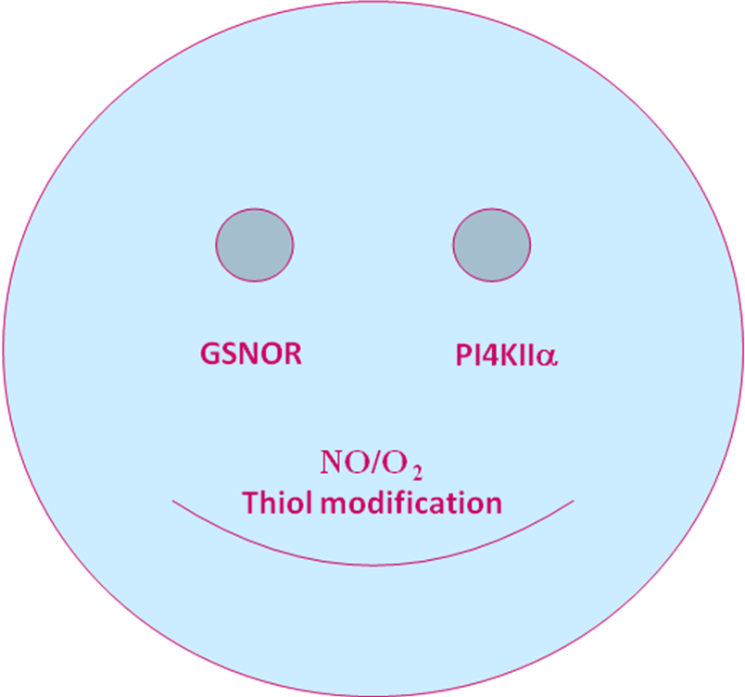
The current research in our group about SNO/thiol modification and the functions of GSNOR and PI4KIIα.
3．论文：
- Mao KR, Chen SZ, Chen MK, Ma YL, Wang Y, Huang B, He YL, Zeng Y, Hu Y, Sun SH, Li J, Wu XD, Wang XG, Strober W, Chen C*, Meng G X*, Sun B*. Nitric oxide suppresses NLRP3 inflammasome activation and protects against LPS-induced septic shock. Cell Research. 2013, 23:201-212.
- Xu Zhang, Bo Huang, Lunfeng Zhang, Yuying Zhang, Yingying Zhao, Xiaofei Guo, Xinhua Qiao, Chang Chen*. SNObase, a database for S-nitrosation modification. Protein and Cell 2012; 3(12): 929–933.
- Xu Zhang, Bo Huang, Chang Chen*. SNO spectral counting (SNOSC), a label-free proteomic method for quantification of changes in levels of protein S-nitrosation. Free Radical Research 2012; 46(8): 1044–1050
- Bo Huang, and Chang Chen*, Function and Mechanism of Nitric Oxide (I)— Characteristics and Function. Acta Biophysica Sinica, 2012. 28(3): 173-184.
- Bo Huang, and Chang Chen*, Function and Mechanism of Nitric Oxide (II)— Mechanism and Protein S-Nitrosation. Acta Biophysica Sinica, 2012. 28(4): 268-277.
- Qinlong Hou, Huoqing Jiang, Xu Zhang, Chao Guo, Bo Huang, Peng Wang, Tiepeng Wang, Kaiyuan Wu, Jian Li, Zhefeng Gong, Libo Du, Yang Liu, Li Liu, Chang Chen*. Nitric oxide metabolism controlled by formaldehyde dehydrogenase (fdh, homolog of mammalian GSNOR) plays a crucial role in visual pattern memory in Drosophila. Nitric Oxide-Biology and Chemistry 2011; (24) : 17-24.
- Xu Zhang, Bo Huang, Xixi Zhou, Chang Chen*. Quantitative proteomic analysis of S-nitrosated proteins in diabetic mouse liver with ICAT switch method. Protein and Cell 2010; 1(7) : 675-87.
- Bo Huang, Chang Chen*. Detection of protein S-Nitrosation using irreversible biotinylation procedures (IBP). Free Radical Biology and Medicine 2010; (49) : 447-456.
- Xixi Zhou, Peiwei Han, Jiangmei Li, Xu Zhang, Bo Huang, Chang Chen*. ESNOQ, Proteomic quantification of endogenous S-Nitrosation. PLoS ONE 2010; 5(4) : e10015. Doi : 10.1371/journal.pone.0010015.
- Jiangmei Li, Yu Lu, Jinhua Zhang, Hua Kang, Zhihai Qin, Chang Chen*. PI4KIIα is a novel regulator of tumor growth via its action on angiogenesis and HIF-1α regulation. Oncogene 2010; (29) : 2550-2559.
- Bo Huang, Jinsong Zhang, Chang Chen* (2010) Induction of Apoptosis in HL60 Cells by Selenosulfate. Acta Biophysica Sinica 26: 316-321.
- Peng Wang, Guang Hui Liu, Kaiyuan Wu, Jing Qu, Bo Huang, Xu Zhang, Xixi Zhou, Larry Gerace, Chang Chen*. Repression of classical nuclear export by S-nitrosylation of CRM1. Journal of Cell Science 2009; 20(122) : 3772-3779.
- Peiwei Han, Xixi Zhou, Bo Huang, Xu Zhang, Chang Chen*. On-gel fluorescent visualization and the site identification of S-nitrosylated proteins. Analytical Biochemistry 2008; 377(2) : 150-155.
- Peiwei Han, Chang Chen*. Detergent-free biotin switch combined with LC-MS/MS in analysis of S-nitrosylated proteins. Rapid Communications in Mass Spectrometry 2008; 22(8) : 1137-1145.
- Shaojin Duan, Chang Chen*. S-nitrosylation/Denitrosylation and apoptosis of immune cells. Cellular and Molecular Immunology 2007; 5(4) : 353-358.
- Jing Qu, Guanghui Liu, Kaiyuan Wu, Peiwei Han, Peng Wang, Jiangmei Li, Xu Zhang, Chang Chen. Nitric oxide destabilizes pias3 and regulates sumoylation. PLoS ONE 2007; 2(10) : e1085. doi: 10.1371/journal.pone.0001085.
- Jing Qu, Guanghui Liu, Bo Huang, Chang Chen*. Nitric oxide controls nuclear export of APE1/Ref-1 through S-nitrosation of cysteines 93 and 310. Nucleic Acids Research 2007; 8(35) : 2522-2532.
- Jie He, Tiepeng Wang, Peng Wang, Peiwei Han, Chang Chen*. A novel mechanism underlying the susceptibility of neuronal cells to nitric oxide: the occurrence and regulation of protein S-nitrosylation is the checkpoint. Journal of Neurochemistry 2007; 6(102) : 1863-1874.
- Bo Huang, Chang Chen*. An ascorbate-dependent artifact that interferes with the interpretation of the biotin switch assay. Free Radical Biology and Medicine 2006; 4(41) : 562-567.
- Chang Chen**, Huang Bo, Peiwei Han, Shaojin Duan. S-nitrosation : The prototypic redox-based post-translational modification of proteins. Progress in Biochemistry and Biophysics 2006; 33 (7) : 609-615.
- Jie He, Hongjun Kang, Fang Yan, Chang Chen*. The endoplasmic reticulum-related events in S-nitrosoglutathione-induced neurotoxicity in cerebellar granule cells. Brain Research 2004; (1015) : 25-33.
- Bo Huang, Jinsong Zhang, Jingwu Hou, Chang Chen*. Free radical scavenging efficiency of Nano-Se in vitro. Free Radical Biology and Medicine 2003; 35 (7) : 805-813.
- Jie He, Peiwei Han, Chang Chen*. Genetic regulation of organ development and programmed cell death. Prog Biochem Biophys 2002; (29) : 970-972.
- Chang Chen, Huiru Tang, Leslie Sutcliffe, Peter Belton. Green tea polyphenols scavenge 1,1-dipenyl-2-picryl-hydrazyl free radicals in the bilayer of liposomes-Direct evidence from ESR studies. Journal of Agriculture and Food Chemistry 2000; (48) : 5710-5714.
- Chang Chen, Taotao Wei, Zhonghong Gao, Baolu Zhao, Jingwu Hou, Huibi Xu, Wenjuan Xin, and Lester Packer. Different effects of the constituents of Egb761 on apoptosis in rat cerebellar granule cells induced by hydroxyl radicals. Biochemistry and Molecular Biology International (IUBMB Life) 1999; 3(47) : 397-405.
- Chang Chen, Xingwang Fang, Yongke He, Jilan Wu. Radiolysis of glycyrrhizic acid monoammonium in N₂O saturated aqueous solution. A product and pulse radiolysis study. Radiation Physics and Chemistry1998; (51) : 49-55.
- Chang Chen, Yongke He, Jilan Wu. Selecting ethanol as a model organic solvent in radiation chemistry-3. Radiolysis of glycyrrhetinic acid (GL)-ethanol system and structure modification of GL by gamma radiation method. Radiation Physics and Chemistry 1998; 2(53) : 151-160.
- Jianghua Feng, Jin Zhao, Fuhua Hao, Chang Chen, Kishore Bhakoo, Huirong Tang. NMR-based metabonomic analyses of the effects of ultrasmall superparamagnetic particles of iron oxide (USPIO) on macrophage metabolism. Journal of Nanoparticle Research 2011; 5(13) : 2049-2062.
- Jie Zhuang, Tianxia Jiang, Di Lu, Yongting Luo, Chaogu Zheng, Jing Feng, Dongling Yang, Chang Chen, Xiyun Yan. NADPH oxidase 4 mediates reactive oxygen species induction of CD146 dimerization in VEGF signal transduction. Free Radical Biology and Medicine 2010; 2(49) : 227-236.
- GuangHui Liu, Jing Qu, Anne E. Carmack, Hyun Bae Kim, Chang Chen, Hongmei Ren, Andrew J. Morris, Brian N. Finck, Thurl E. Harris. Lipin proteins form homo-and hetero-oligomers. Biochemal Journal 2010; (432) : 65-76.
- Shaojin Duan, Lin Wan,Wenjiang J. Fu, Hong Pan, Qi Ding, Chang Chen, Peiwei Han, Xiaoyan Zhu, Liying Du, Hongxiao Liu, Yuxia Chen, Ximing Liu, Xiting Yan, Minghua Deng, Minping Qian. Nonlinear cooperation of p53-ING1-induced bax expression and protein S-nitrosylation in GSNO-induced thymocyte apoptosis : a quantitative approach with cross-platform validation. Apoptosis 2009; 14 (2) : 236-45.
- Taotao Wei, Chang Chen, Jingwu Hou, Wenjuan Xin and Akitane Mori. Nitric oxide induces oxidative stress and apoptosis in neuronal cells. Biochimica et Biophysica Acta-Molecular Cell Research 2000; (1498) : 72-79.
- Chunyang Zhang, Taotao Wei, Hui Ma, Chang Chen, Wenjuan Xin, Dieyan Chen. A photoelectric method for analyzing NO-induced apoptosis in cultured neuronal cells. Electroanalysis 2000; (12) : 1414-1418.
- Taotao Wei, Wenjuan Xin, Jingwu Hou, Chang Chen, Akitane Mori. EPC-K1 protects neuronal cells from peroxynitrite-mediated oxidative damage. Research on Chemical Intermediates 2000; (26) : 667-677.
- Taotao Wei, Chang Chen, Jingwu Hou, Baolu Zhao, Wenjuan Xin. Nitric oxide damages neuronal mitochondria and induces apoptosis in neurons. Chinese Science Bulletin 2000; (45) : 422-426.
- Taotao Wei, Jingwu Hou, Chang Chen, Baolu Zhao, Wenjuan Xin. The antioxidant Egb761 prevents peroxynitrite-induced apoptosis in rat cortical neurons. Medical Science Research 2000; (28) : 93-95.
- Taotao Wei, Yucheng Ni, Jingwu Hou, Chang Chen, Baolu Zhao, Wenjuan Xin. Hydrogen peroxide-induced oxidative damage and apoptosis in cerebellar granule cells: protection by ginkgo biloba extract. Pharmacological Research 2000; 41(4) : 427-433.
- Wenjuan Xin, Taotao Wei, Chang Chen, Yucheng Ni, Baolu Zhao, Jingwu Hou. Mechanism of apoptosis in rat cerebellar granule cells induced by hydroxyl radicals and the efffects of EGb761 and its constituents. Toxicology 2000; (148) : 103-110.
- Taotao Wei, Chunyang Zhang, Jingwu Hou, Changchen, Hui Ma, Dieyan Chen, Wenjuan Xin. Reactive oxygen species are involved in nitric oxide-induced apoptosis in rat cortical neurons. Research of Chemistry Intermediate 2000; 26(9) : 875-883.
- Taotao Wei, Chang Chen, Fengmei Li, Baolu Zhao, Jingwu Hou, Wenjuan Xin, Akitane Mori. Antioxidants properties of EPC-K1: a study on mechanism. Biophysical Chemistry 1999; (77) : 153-160.
- Taotao Wei, Chang Chen, Jingwu Hou, Baolu Zhao, Wenjuan Xin, Akitane Mori. The antioxidant EPC-K1 attenuates NO-induced mitochondrial dysfunction, lipid peroxidation and apoptosis in cerebellar granule cells. Toxicology 1999; (134) : 117-126.
- Guangyin Zhou, Baolu Zhao, Jingwu Hou, Meifen Li, Chang Chen, Wenjuan Xin. Detection of nitric oxide in tissue by spin trapping EPR spectroscopy and triacetylglycerol extraction. Biotechnology Techniques 1999; (13) : 507-511.
- Taotao Wei, Chang Chen, Yongjin Huang, Baolu Zhao, Jingwu Hou, Wenjuan Xin, Akitane Mori. EPC-K1 prevents ONOO-induced apoptosis in cerebellar granule neurons ACTA. Biochimicaet Biophysica Sinica 1999; (31) : 239-244.
- Taotao Wei, Chang Chen, Jingwu Hou, Baolu Zhao, Wenjuan Xin. NO-induced mitochondrial dysfunction and apoptosis in cerebellar granule cells. Science Bulletin 1999; ( 44) : 1867-1871.
- Taotao Wei, Chang Chen, Baolu Zhao, Wenjuan Xin, akitane Mori. EPC-K1 attenuates peroxynitrite-induced apoptosis in cerebellar granule cells. Biochemistry and Molecular Biology International (IUBMB Life) 1998; 46(1) : 89-97.

